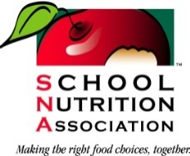

SNA Membership – Elevator Speech
You have such an important job serving school meals to our nation’s children. By belonging to SNA, you are part of something bigger than just your school or district. You are joining the 57,000 committed members from across the county who are feeding the future. You represent all of the hungry children who eat at school and your voice matters.
Also, by being a member of SNA, you get a support network of friends who understand the everyday challenges of the cafeteria and access to resources that help make your job easier. This includes a monthly magazine, free webinars and e-newsletters. All of this for less than 14 cents per day!
[CUSTOMIZE] I love being a SNA member because. . .OR I have benefitted from SNA membership because. . . OR My favorite thing about being a SNA member is. . . [Make your story personal! Speak about what YOU have gotten out of your SNA membership!]

NEXT STEPS: Give the relevant membership materials and new member application to the prospective member and ask them to sign up! It is also good to have your business card (contact details) handy in case they have follow-up questions.

Note: If a District offers an incentive for having a certificate in school nutrition, this would be the main membership driver. The certificate application and renewal fees are reduced for an active member. In this instance a Certificate Program Guide and membership application would be the best materials to provide.

